Project Portfolio
NHS Wood Green
London

Scope of works:

- Supply, install and commission of 4 x LG Condensers serving AHU for landlord of Wood Green Shopping Mall supplying them with both heating and cooling. Condensers consisted of ARUM200LTE5, ARUM200LTE5, ARUM140LTE5 & ARUM120LTE5. System also included 4 x PRLK096A0 expansion valves. On commissioning we worked in partnership with BMS controls contractors and manufacturers commissioning engineer. See below schematics/photos of our works:

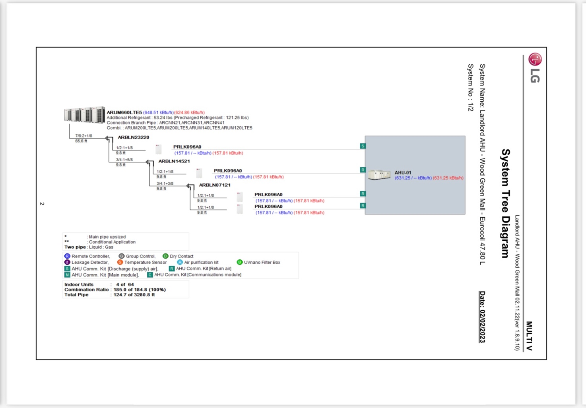
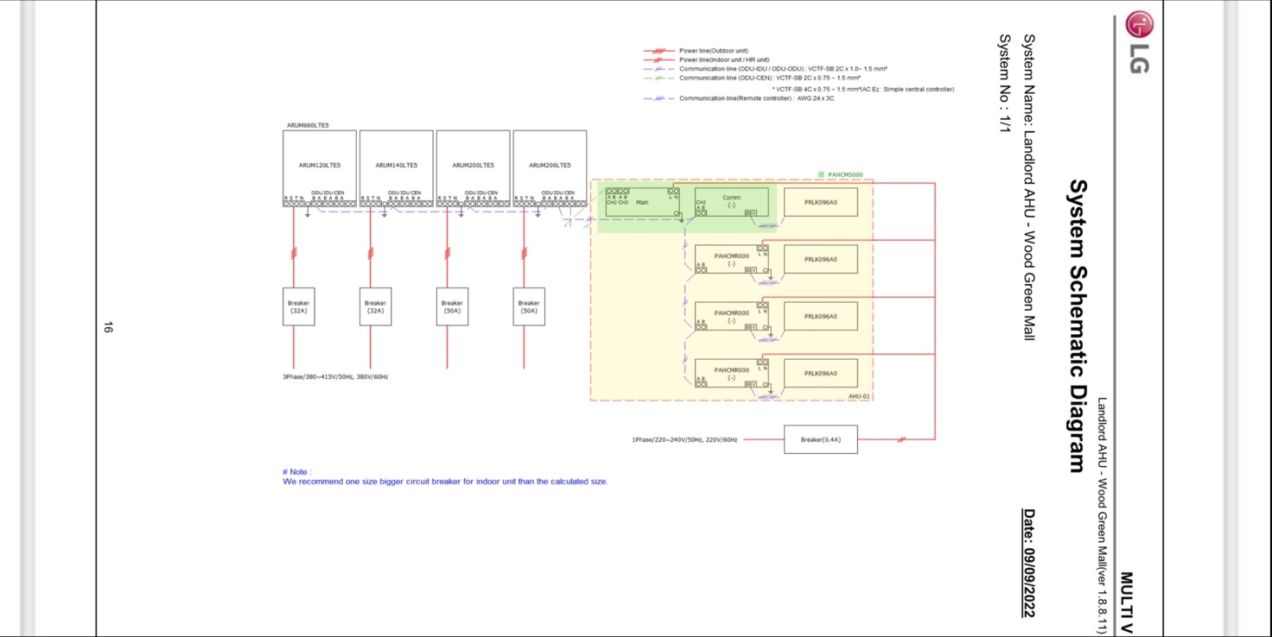
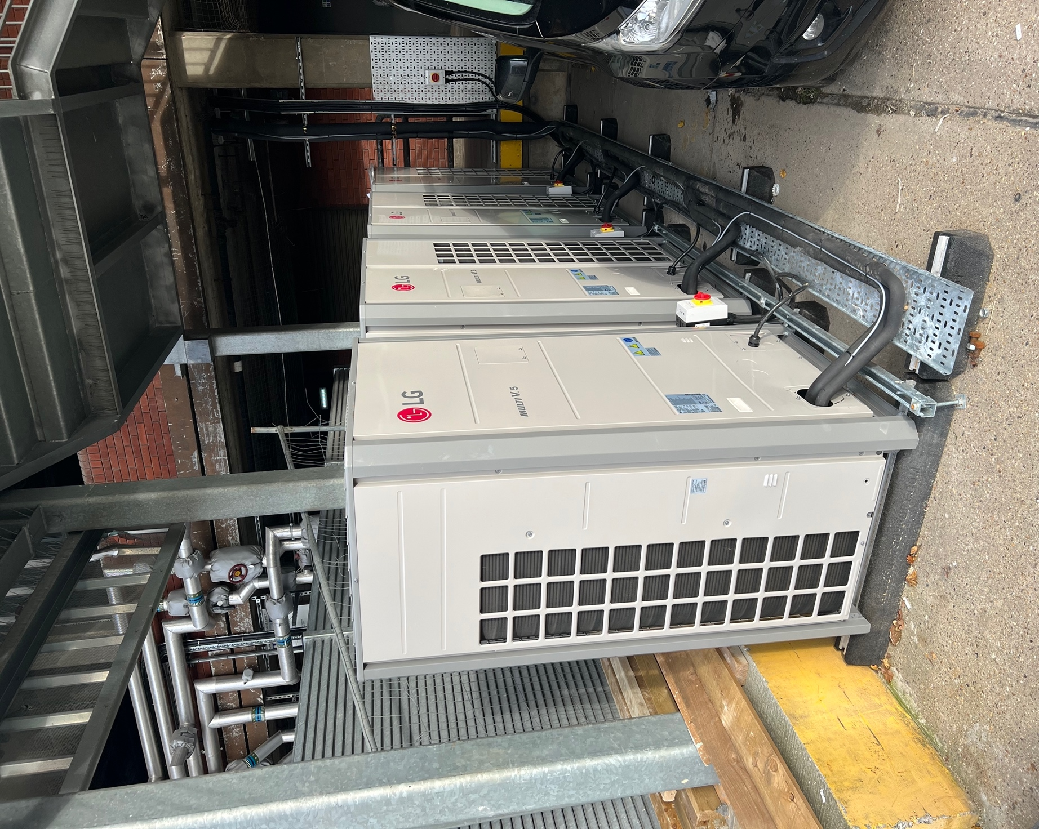
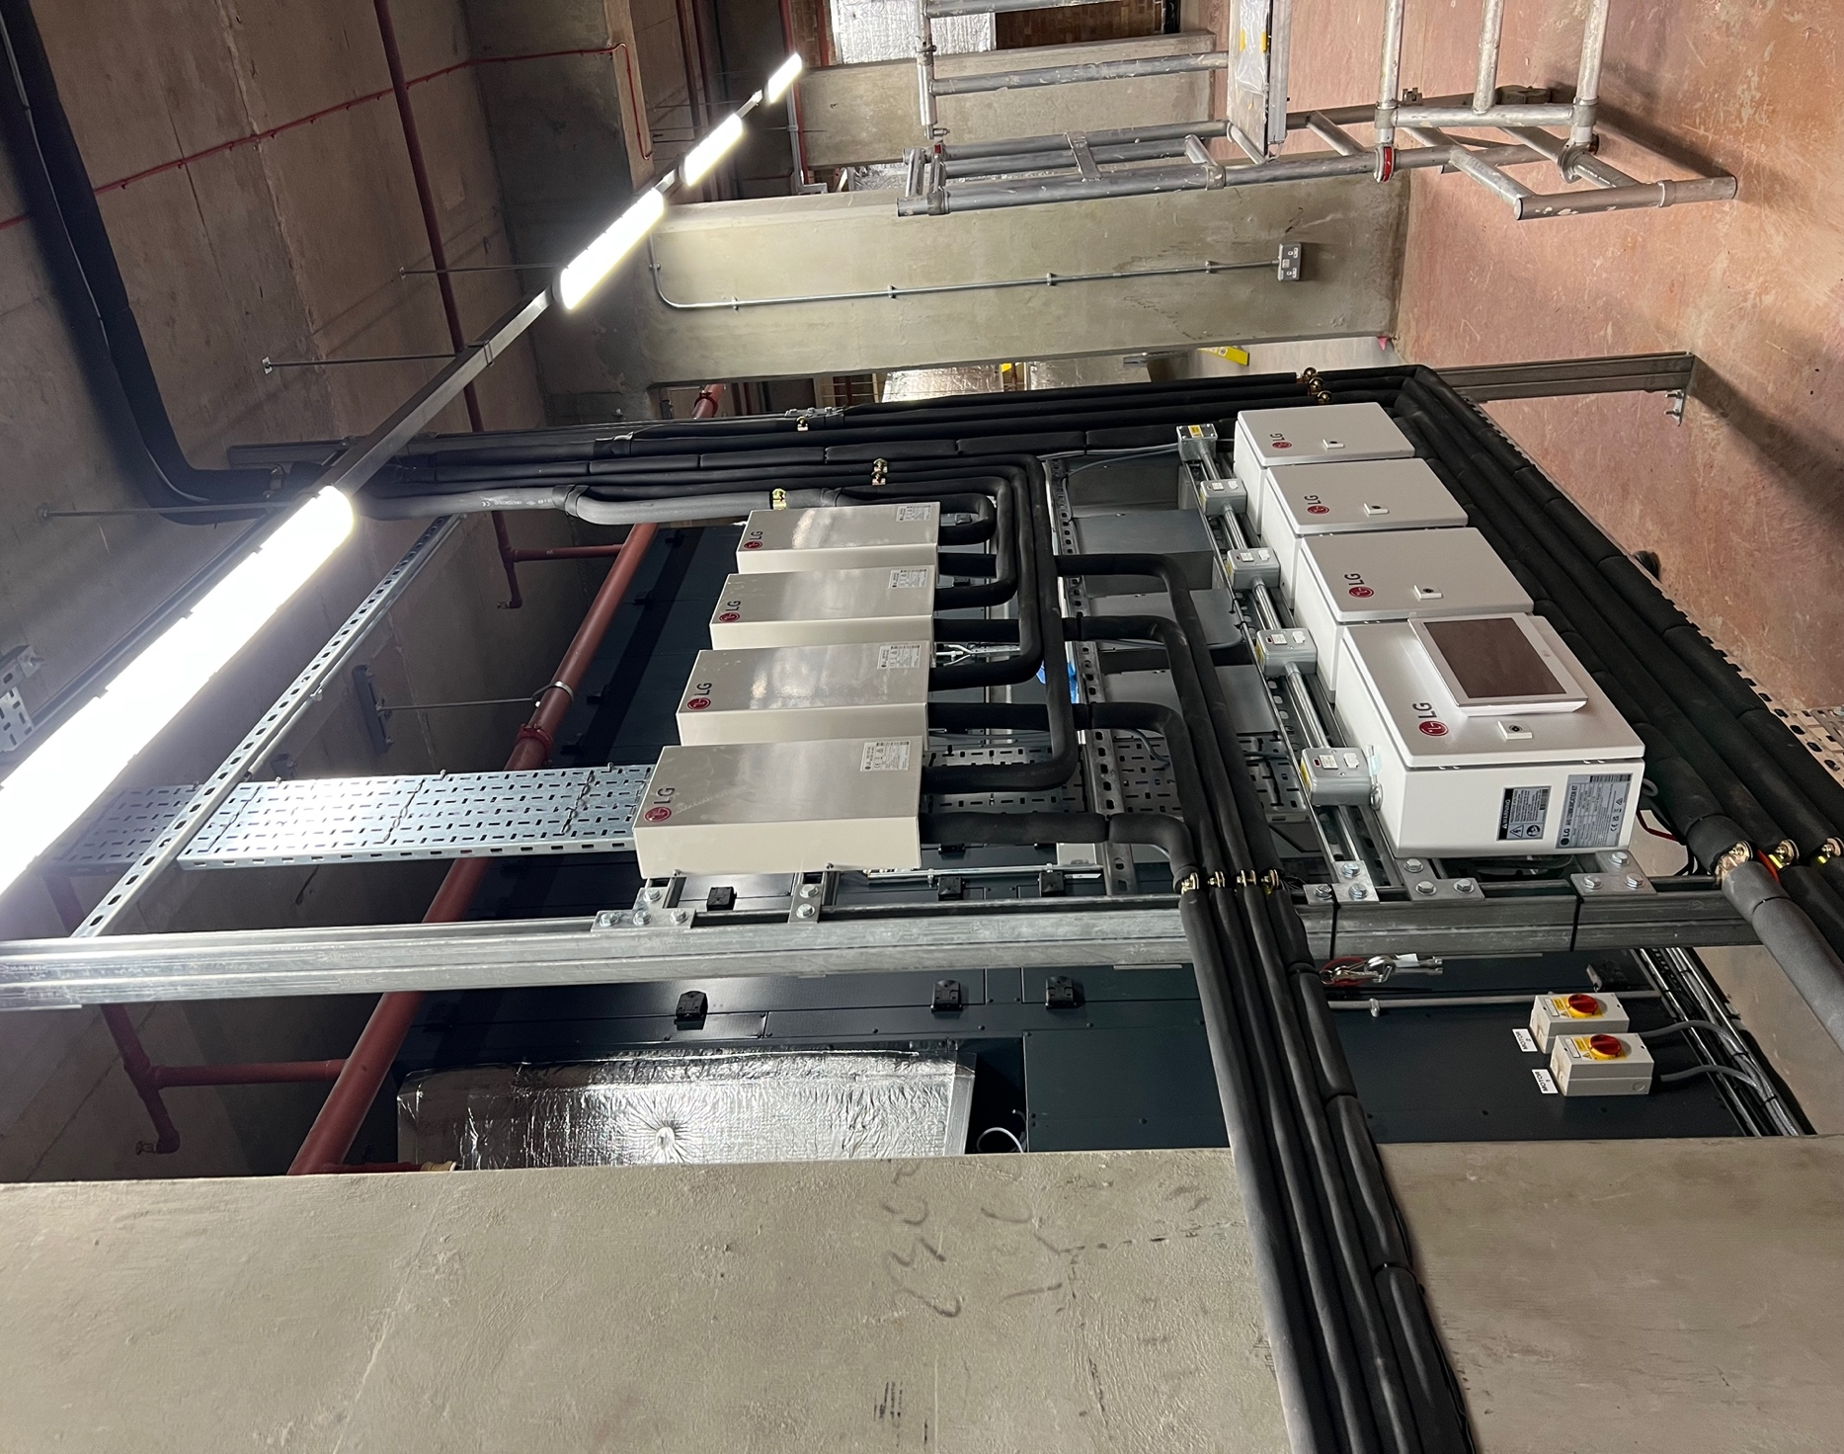
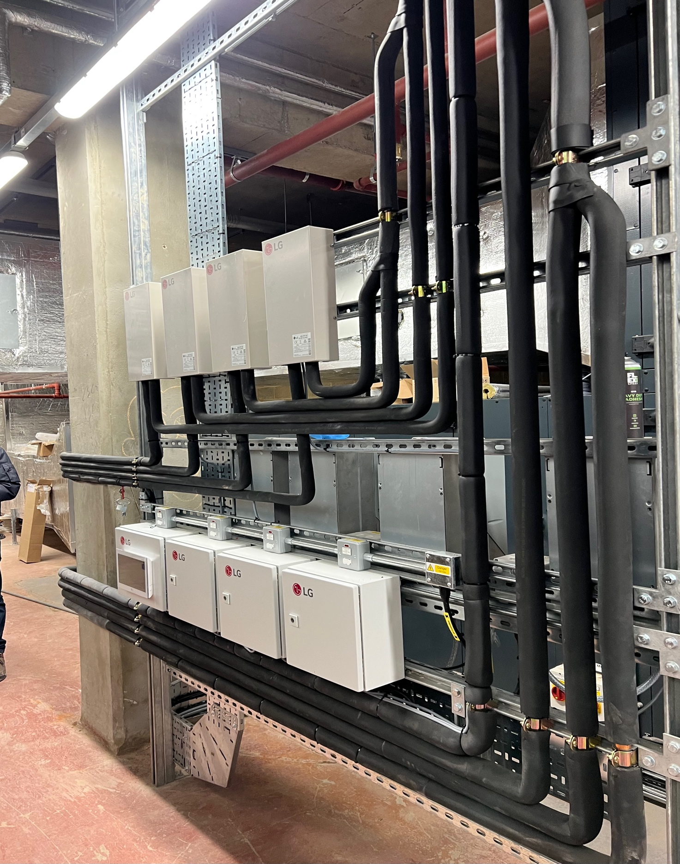
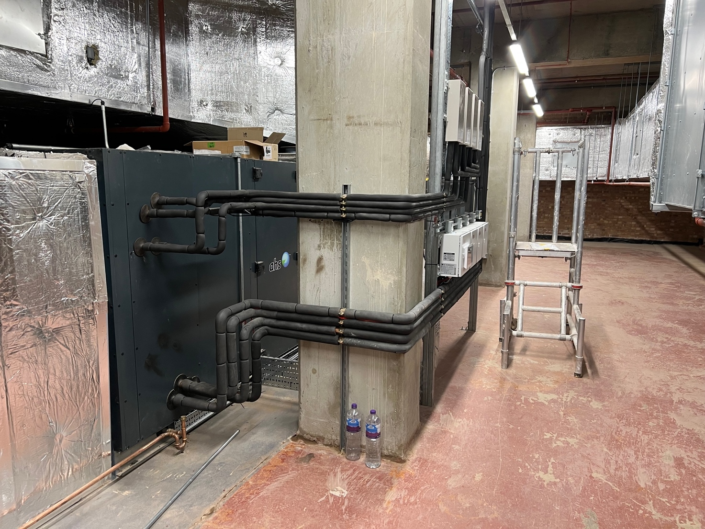
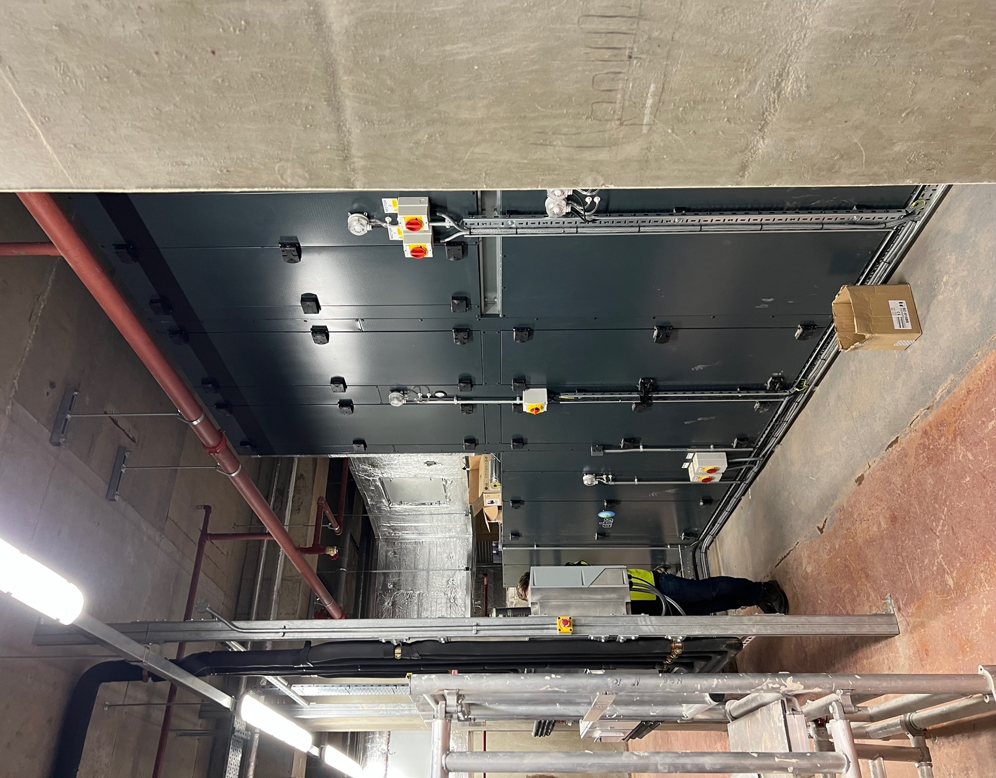

- Supply, install and commission of 2 x Toshiba VRF systems consisting of 20 FCU units ranging from Ducted, Under ceiling or Wall mounted units which serve NHS wood green community hospital. See below drawings/photos:

